ENR210 Continuum Mechanics
Group 11
“Vision-based surface deformation tracking for gesture control”

- Objective:

This experiment aims at real-time surface deformation tracking using the vision to the gesture control applications. The aim is to determine deformation by observing the marker points on a deformable surface with a phone camera, calculate displacement and strain and compare the observed deformation with applied force/pressure using the principle of continuum mechanics.

Gesture recognition systems need the small surface deformations detection on human skin. This experiment uses a simplified controlled deformation to measure deformation with the help of computer vision and a simplified controlled deformation to illustrate the same.

- Methodology:

    - Experimental Approach

The experiment was initially planned to use the deformation of human hand/skin as a gesture controller. However, deformation of hand skin is small, non-uniform and dependent on lighting and motion noise. Therefore, it cannot be easily tracked.

Thus, a balloon membrane was chosen, as it demonstrates greater, smoother, and uniform deformation upon inflation/deflation, which allows to track movement of markers easily and can be measured with a simple camera arrangement.

    - Material used
- Rubber balloon
- Permanent marker (for black dots)
- Smartphone camera (video recording)
- Fixed stand/tripod
- Laptop with Python installed

    - Experimental Procedure
- The black marker points were put on the surface of the balloons.
- The camera was placed in a fixed position to prevent movement of the camera.
- The video recording began with an undeformed balloon.
- The balloon was inflated slowly and noted.
- The deflation of the balloon was then recorded.
- The video captured was run through frame by frame using Python.
- The marker points were observed and measured.
- Strains and displacement were determined.
- Deformation plots were drawn and analyzed.
    - Image Processing Method

OpenCV was used to track them through the use of point tracking.
Steps performed in Python:
- Detect coordinate of marker point in the first frame.
- Optical flow motion Tracking of the markers points in the next frame.
- Store frame coordinate.
- Calculate displacement and strain using coordinate measurements.
- Produce plots and video tracked output.

    - Software and Libraries Used

- Python
- OpenCV (cv2)
- NumPy
- Matplotlib
- Pandas

    - Governing Theory and Equations
- Displacement Field:
In continuum mechanics, deformation will be,
$$x=X+u$$
Where:
X = original position,
x = deformed position,
u = displacement vector.
Component form:
$$u=x-x_{0},v=y-y_{0}$$

- Displacement Magnitude:
$$∣u∣=\sqrt{u^{2}+v^{2}}$$

- Strain Calculation:

Engineering strain between two markers will be,

$$ε=\frac{L-L_{0}}{L_{0}}$$

Where initial and final distances are,

$$L=\sqrt{\left(x_{2}-x_{1})^{2}+(y_{2}-y_{1})^{2}\right.}$$

- Stress–Strain Relation:
$$σ=Eε$$

- Balloon Membrane Stress:

For a thin spherical membrane,

$$σ=\frac{Pr}{2t}$$
Where:
P= internal pressure,
r= balloon radius,
t= balloon thickness.
- Result interpretation:

    - Observations:

      - When inflation occurred, the marker points were separated showing surface stretching.
      - When size of balloon was increasing, displacement also increased.
      - In the process of deflation, the displacement decreased and points went back to where they were initially.
      - The values of strain varied with the size of the balloon which proved the stretching behavior.
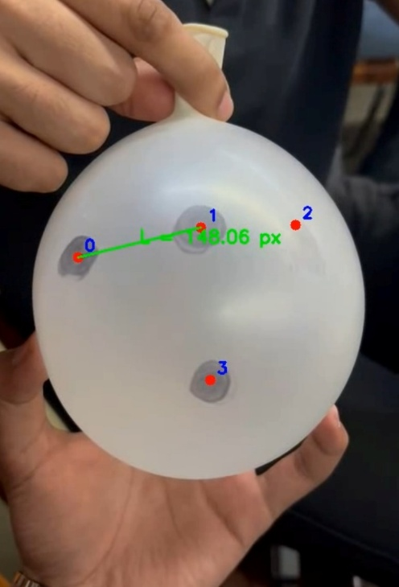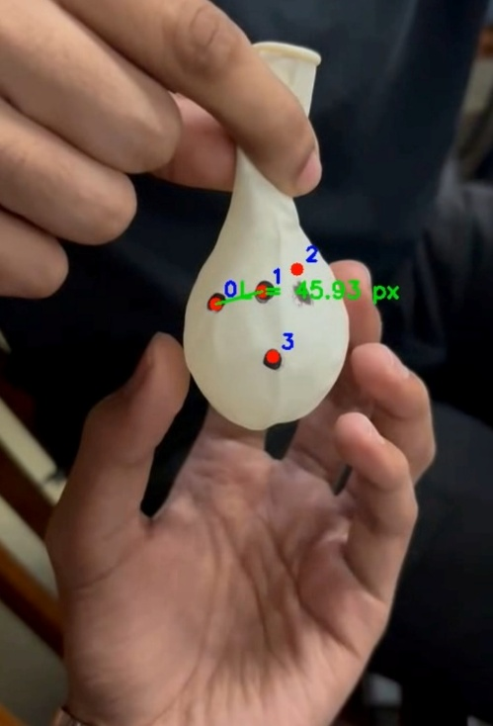

    - Displacement Analysis:

Results of tracking displacement values indicated a clear increase with time in the inflation period. It was observed that the displacement field was smooth, and this proves that the balloon acts as a continuous deformable body.
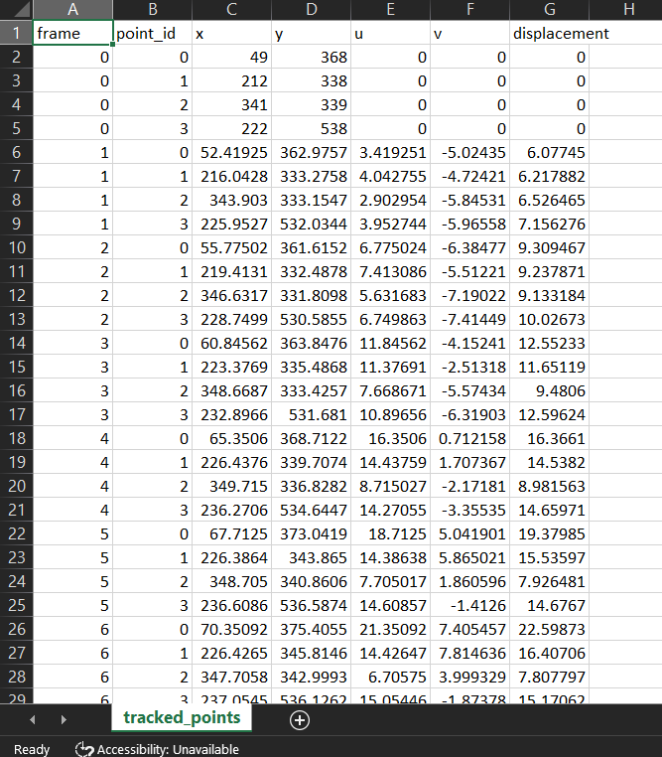

    - Strain Analysis:

Calculation of strain based on change of distance between marker points indicated that strain increased with inflation and reduced with deflation.

This validates:
$$P↑⇒σ↑⇒ε↑$$
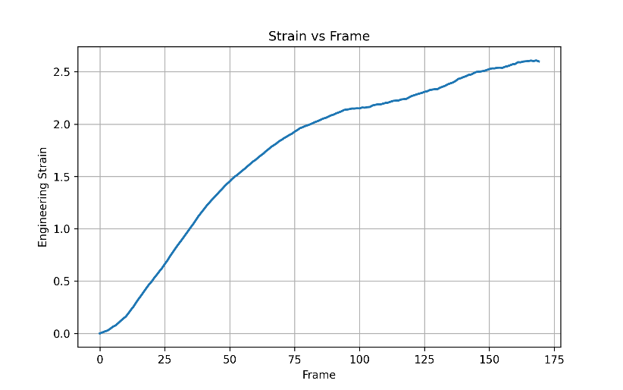
Inflation
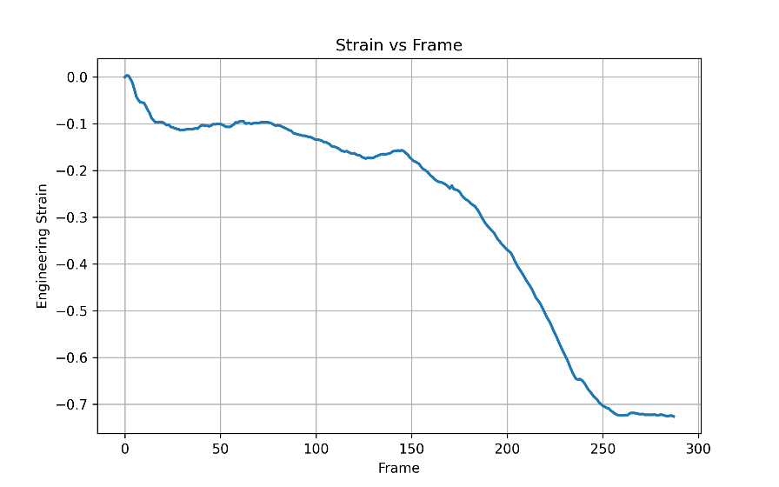
Deflation

    - Continuum Mechanics Stress and Force Estimation:

The balloon is a deformable membrane. The tensile stress that develops on the surface is caused by internal pressure and causes stretching. The obtained strain values confirm the continuum mechanics relationship between deformation, pressure and stress.

    - Interpretation Applications Interpretation:
This method can be applied for:
- Gesture recognition using skin deformation
- Wearable sensor-free strain measurement
- soft robotics deformation monitoring

    - Continuum Mechanics Stress and Force Estimation:
      - Inflation:
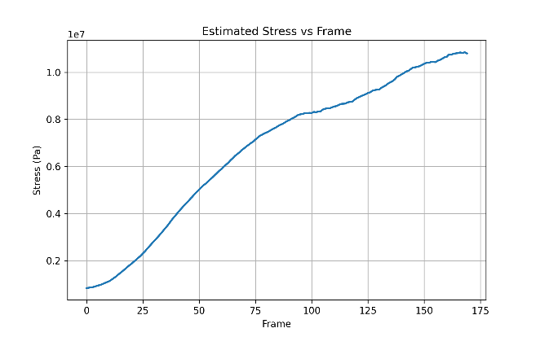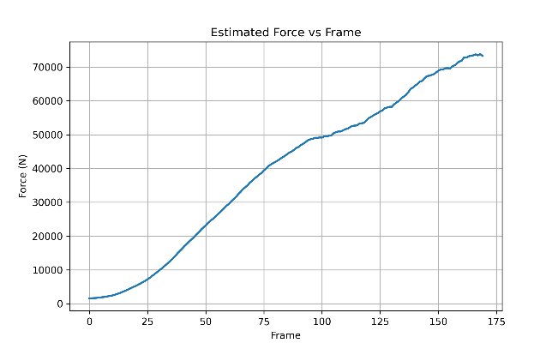

- Deflation:
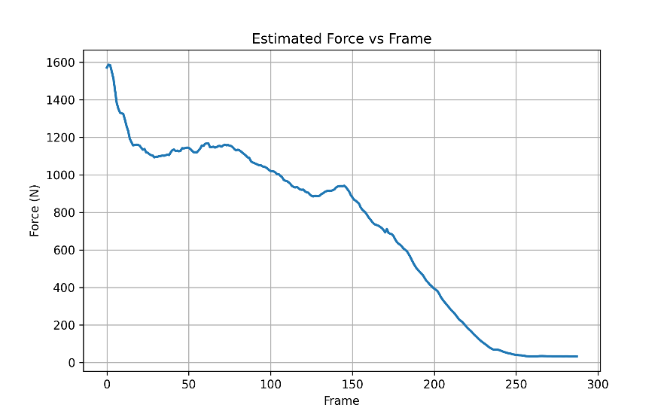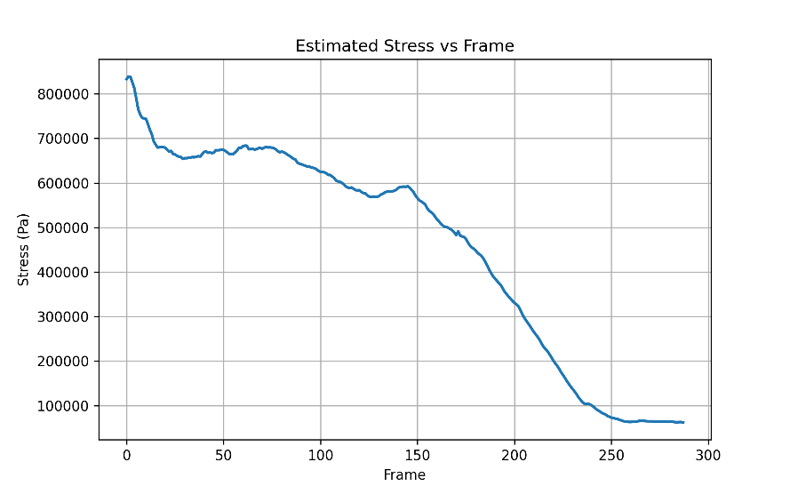

- Conclusion:

This experiment was effective in showing a vision-based system of deformation measurement which involves tracking of markers and image processing. Video frames were used to track marker displacement and used to determine displacement and strain. The balloon membrane was visibly deformed during the process of inflation and deflation thus it could be used to measure it accurately.

This experiment was effective in showing a vision-based system of deformation measurement which involves tracking of markers and image processing. Video frames were used to track marker displacement and used to determine displacement and strain. The balloon membrane was visibly deformed during the process of inflation and deflation thus it could be used to measure it accurately.

- Contribution of each member:

Chintan Thacker [AU2440215]: - Report
Fenil Patel [AU2440042]: - Report
Parthiv Karangiya [AU2440016]: -Code
Pratik Agrawal [AU2440043]: - Code
Aadi Mehta [AU2440105]: -Poster
Patel Lay Yogeshbhai [AU2440258]: -Poster

- Video link:

- https://drive.google.com/drive/folders/1MZB4BA_drxWxgAX2feLNg6OXPm-C0pds
Github link:
- https://github.com/parthiv9899/vision-based-deformation-tracking

